Dalton Murray, Norhan John

Systems Analysis and Design

INT 6123 – Systems Analysis and Design

Dr. Andrew Makar

September 24, 2023

**Case Study 1**

**System Vision Document**

Problem Description

Makar Motors is using an outdated time approval process along with their monthly invoices, we need to create an updated process for them which allows them to have mass approval and rejection capabilities, it also allows all employees to track time and which project they are working on for that time.

The current system is also faced with having inaccurate times which need to be fixed with the new system. The system for receiving and sending current timecards with invoices is also slow and outdated, the company receives invoices and timecards from a separate contracted company on a monthly basis with an excel sheet of all needed information, this existing system is slow and does not work well for the company. There is also only one person who is able to approval time as of right now, however, there needs to be able to be a way to assign a delegate so that another manager is able to approve time as needed. Currently, this system also has multiple different forms and sheets getting submitted which causes delays when trying to piece prices, hours, time, and invoices together, these need to all be reconciled so that they are together in one logically formatted document.

With the current system, it also takes the IT manager a large amount of time in order to approve time on a weekly basis, we need to be able to ensure that it is being completed in a more efficient manner.

The employees themselves also have difficulties with the current system as it is not easy to enter in the times they’ve worked, it is also often containing inaccurate data. The employees also are often submitting time when they are not at a computer and need to be able to submit time when they are on-the-go using a mobile device.

Scope

The scope of this project which we have been hired on by Makar Motors to conduct the systems analysis and design phase of a new time tracking system. The system must be efficient, accurate, versatile, logical, and consist of many capabilities such as mass approval and rejection, time keeping, document consolidation, alerts/reminders, profiles and skills inventory, delegation, and time off/sick leave/vacation requests.

System Capabilities/Requirements/Needs

* Analyze and design an up-to-date time tracking system
  + Designed to be efficient and accurate
    - Employees should be able to enter and correct the times they’ve worked in an easy way
      * Initially, employees will sign in on the system and sign out so that the system has a base amount of hours worked which they can later correct and can modify if they have overtime
      * They will also have a button to say when they are going on a break and coming back from the break so the system can log the time
    - The system needs to be able to be smart enough to see if the times they’ve entered may be incorrect
      * This is based off of patterns, requested time off, sick leave, overtime, and standard hours in a week for their position/average of employees in department
    - There also needs to be a mass time approval and rejection subsystem
  + The system needs to be alerts and notifications/reminders going to the IT manager to tell him when pay periods are so that it makes sure everything is done on a weekly basis
  + Design of the system needs to be versatile
    - We must be able to support the use of desktops, laptops, tablets, and phones on the new system
  + The formatting of the final document needs to be logical
    - Time cards, worked hours, invoices, projects works all need to be in a single well thought out document/viewable system
  + We also need a profile and skills inventory
    - We need to know who is working on what, what resources are available
    - We need to know who has what skills and what people are doing so that we can assign them to new projects for easier tracking
  + The system needs to be able to have a delegate
    - The IT manager needs to be able to assign a delegate so that they can approve/reject time
  + Time off/vacation
    - Employees must be able to request having time off/days off, and select vacation days
      * Manager/supervisor approval and rejection
    - Employees can put comments with their requests
    - Employees can also submit proof of sick leave/medical documents
  + Overtime/shift requests
    - Employees can submit overtime requests with their hours
    - Employees can also request additional shifts if they want them, and be able to exchange with other employees
  + Timezones
    - The system will automatically handle timezones allowing for ease of use
  + Tasks
    - Allows the ability for management to assign tasks to employees so that they can go back to it and have a log of what they have done and need to do
    - Timeline system
      * These tasks can also have deadlines/dates set on them with reminders of when someone is running behind
    - Priority
      * The system will also have priorities so that they can be assigned a priority and know what to do first and what is needed immediately
  + Security
    - We want to ensure that everything on the time tracking system and all subsystems are secure, all passwords and traffic encrypted

Business Benefits

As a result of the system, Makar Motors staff would save a lot of time as well as money wasted as a result of the time needed to currently submit, approve, and correct invoices and time. This system will also be able to provide an efficient and good way for employees to accurately report time worked if not already accurate by the system after we change how it is automatically handling time. This system will also help reduce stress in employees, supervisors, and managers as it will aid in automatically handling time, money, and invoices for them.

**Activity diagram**

Due to sizing of the image, attaching the image into Word isn’t the best way to view it so there will be an additional attached image file included while also including the file into this document.

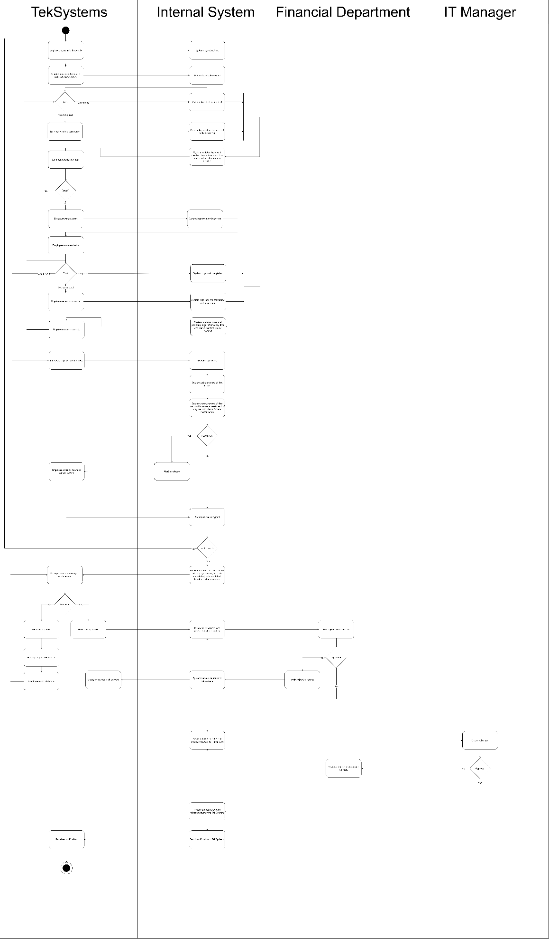

**User Stories and Acceptance Criteria**

|  |
| --- |
| **User Story 1:**  As a manager, I want to assign tasks to employees so I can track their work progress and deliverables.  **Acceptance Criteria:**   1. A manager can create a list of tasks with a title and description for each, highlight top priority tasks, and add a deadline. 2. A manager can assign tasks to specific employees to work on. 3. A manager can mark the tasks as complete or incomplete and can provide comments and feedback. 4. A manager can adjust, edit, or delete tasks as necessary. 5. A manager can receive and view any input from employees regarding the tasks. 6. A manager can avoid or limit project delays by creating alerts and reminders. |

|  |
| --- |
| **User Story 2:**  As a staff member, I want to be able to view my schedule, my assigned tasks and track my time so I can plan and set my goals for the day.  **Acceptance Criteria:**   1. A team member can launch the system smoothly from any device. 2. A team member can track their login time, time spent on a task, break time, and log out time. 3. A team member can view their assigned tasks with the deadline time and view team members to communicate effectively. 4. A team member can receive notifications and alerts when a new task is created, or a task is edited or updated. 5. A team member can input comments, questions, and updates regarding a task. 6. A team member can receive and view feedback from the manager. 7. A team member can request time off, vacation, time extensions, and overtime. 8. A team member can input their availability and work area preferences. 9. A team member can submit attachments and reports. |

|  |
| --- |
| **User Story 3:**  As a scheduling manager, I want to be able to smoothly manage staff availability and hours, so that I can assign shifts to employees as needed.  **Acceptance Criteria:**   1. A scheduling manager can assign shifts to staff members indicating their main role, start and end time, department, and location. 2. A scheduling manager can schedule team members based on their time and work area preferences and based on their experience and skills. 3. A scheduling manager can approve or reject time off, vacation, and overtime requests from the staff and provide comments. 4. A scheduling manager can assign members breaks specifying start and end time. 5. A manager can avoid or limit project delays by creating alerts and reminders. 6. A scheduling manager can delete shifts if no longer needed or adjust and edit existing shifts. |

|  |
| --- |
| **User Story 4:**  As the financial manager, I want to accurately manage hours and invoices, so that I can generate payable statements.  **Acceptance Criteria:**   1. A financial manager can view timecards for each staff member for each pay period. 2. A financial manager can view the total payroll cost of the company and for each member. 3. A financial manager can modify and correct timecards. 4. A financial manager can generate accounts payable statement based on timecards. 5. A financial manager can submit payable statements into the system to the staffing provider. 6. A financial manager can check whether time billed is accurate or not before IT managers approve it. |

|  |
| --- |
| **User Story 5:**  As an IT manager, I want to direct online operations and evaluate investments and IT needs so I can help improve the company’s productivity, reliability, security, and efficiency.  **Acceptance Criteria:**   1. An IT manager can easily track time and do mass approval all at once. 2. An IT manager can delegate time approvals to other managers in case the responsible manger is absent or on vacation. 3. An IT manager can smoothly send data files to the vendor that includes hours, rates, and the total invoice. 4. An IT manager can develop and update security measures and IT policy. 5. An IT manager can schedule system update, outages, and migrations. |

|  |
| --- |
| **User Story 6:**  As a resource manager, I want to track different projects done by team members and how much time they spend so I can enhance staff productivity and efficiently distribute resources.  **Acceptance Criteria:**   1. A resource manager can build profile and skills inventory to track project progress. 2. A resource manager can view an employee’s total hours spent on a project. 3. A resource manager can assign tasks for a project manager, developer, and system analyst. 4. A resource manager can manage staff workload and view the status for each project. 5. A resource manager can view staff availability and when anyone is free for another project. |

|  |
| --- |
| **User Story 7:**  As an account manager at TekSystems, I want to view my staff’s performance metrics so I can identify any issues and evaluate my staff efficiency and productivity.  **Acceptance Criteria:**   1. An account manager can easily track and enter time data. 2. An account manager can access the system from a mobile application and can have a mobile view. 3. An account manager can receive notifications and alerts when her consultants update their time sheet while waiting for their flight. 4. An account manager can get reports about a team member’s performance and clients’ rating and satisfactions. 5. An account manager can view clients’ user profile to easily communicate with them and address any project issues or risks and provide status updates and milestones. |

**Trello**

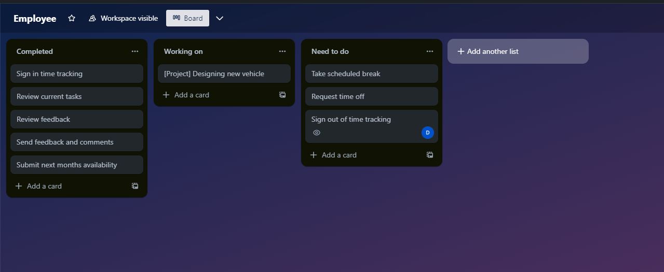

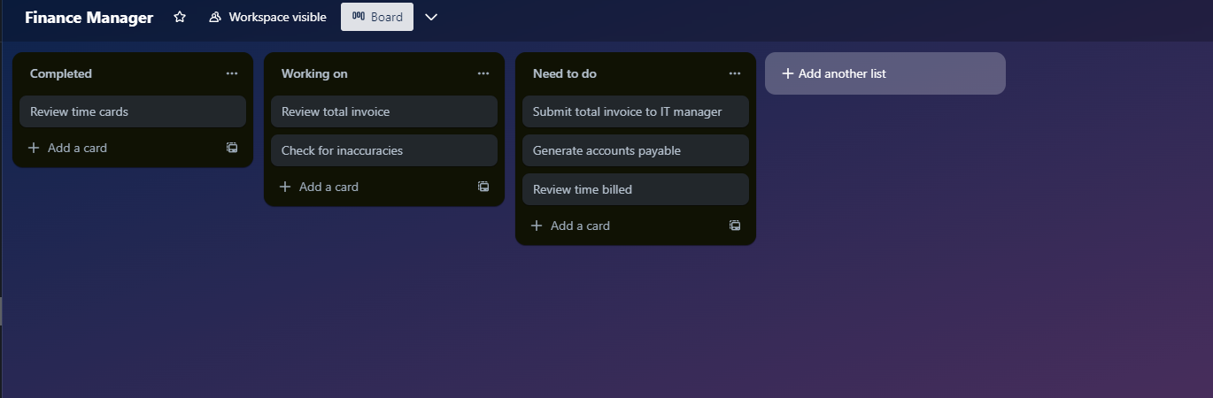

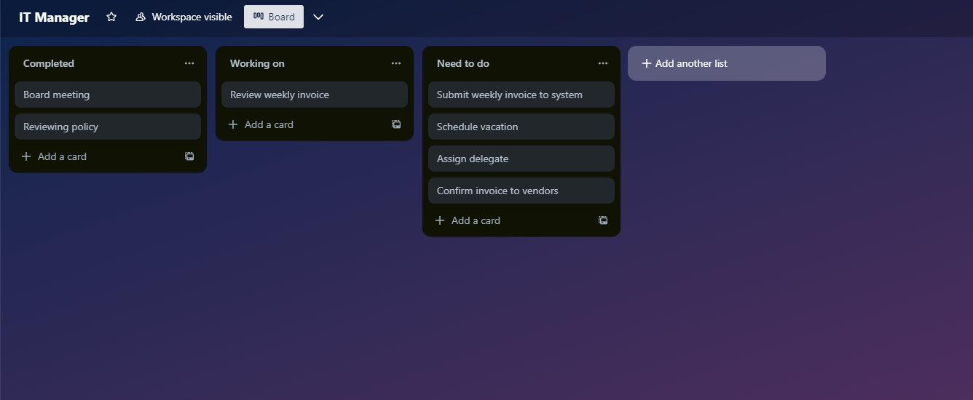

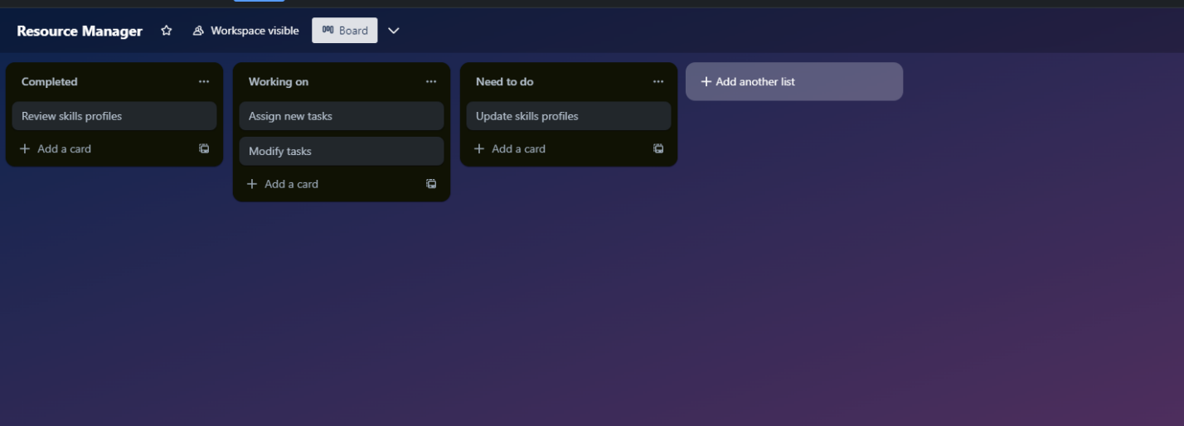

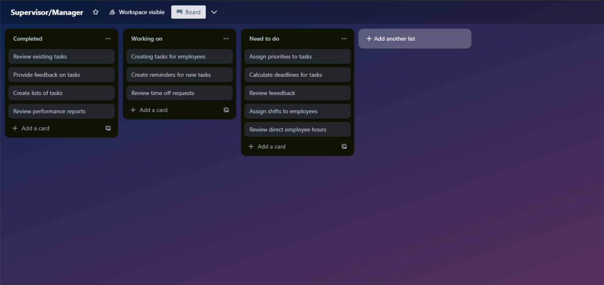

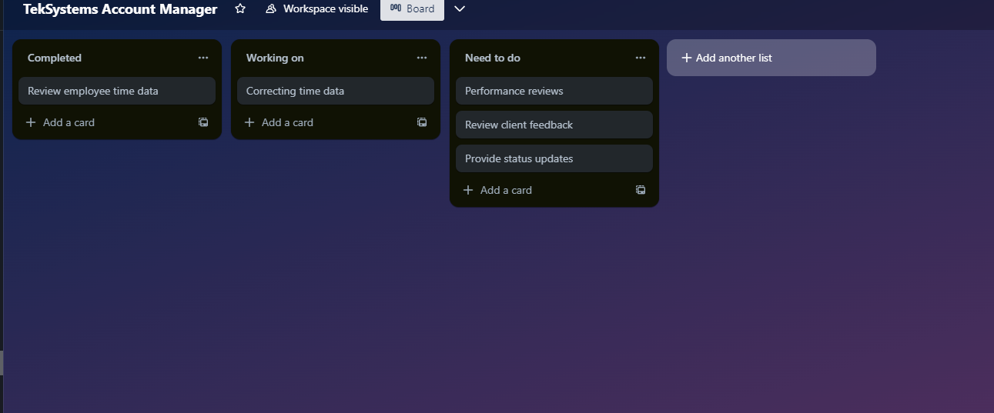

**Use case diagram**

Due to sizing of the images, attaching the image into Word isn’t the best way to view it so there will be an additional attached image file included while also including the file into this document.

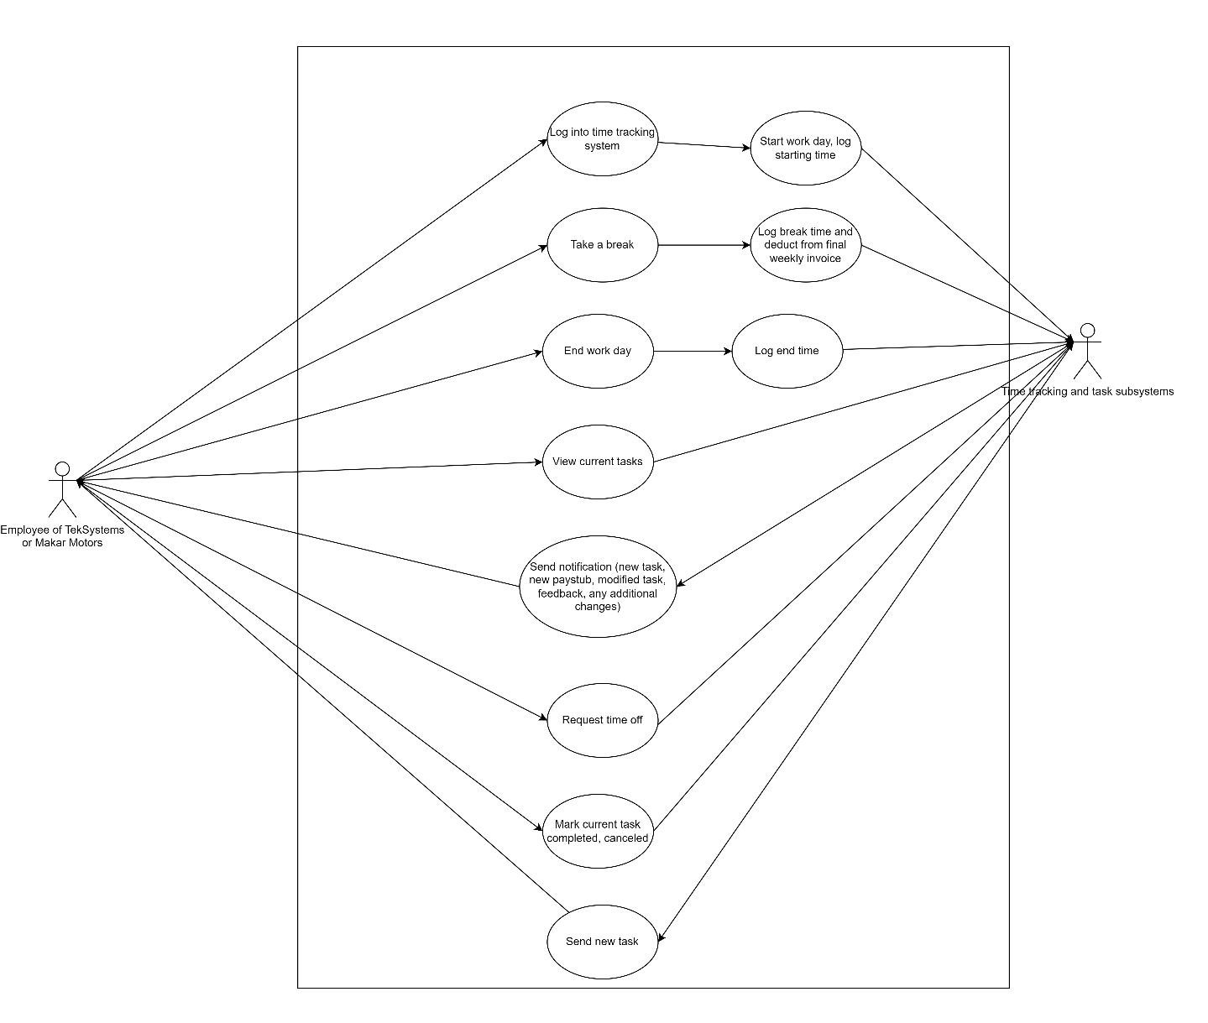

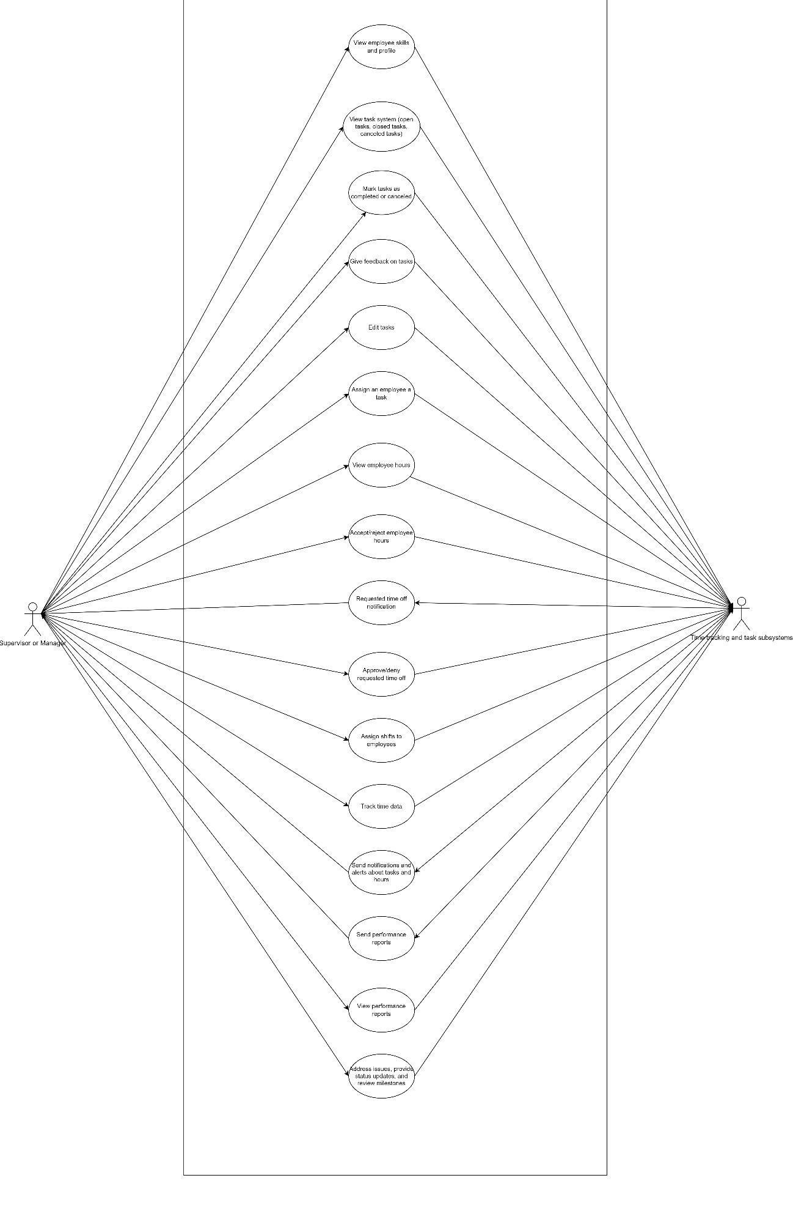

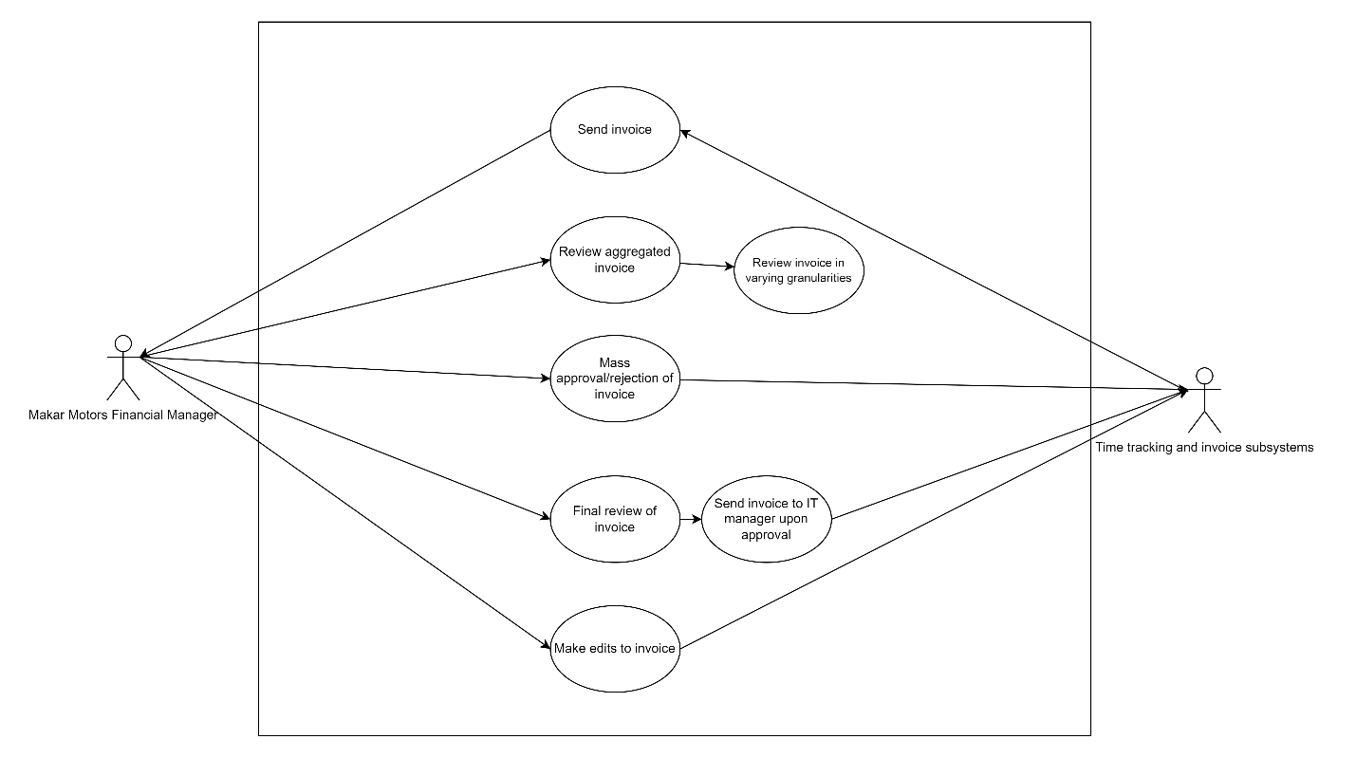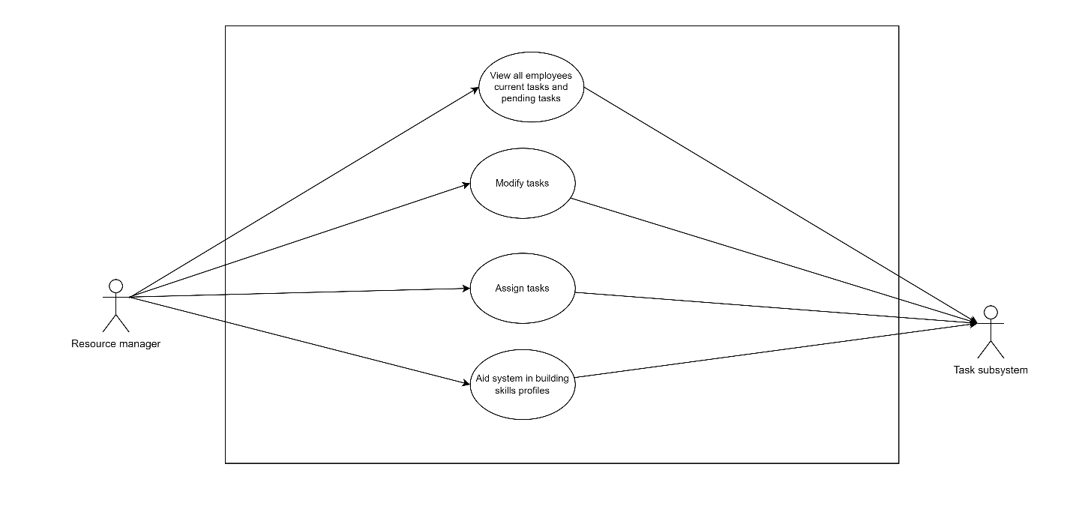

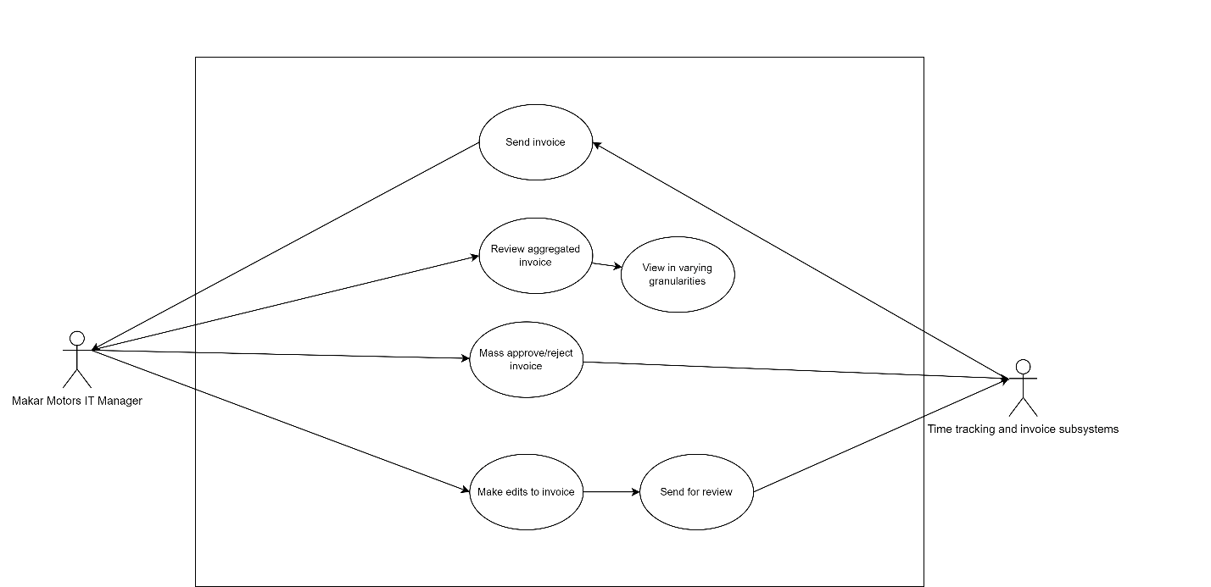

I have neither given nor received unauthorized aid in completing this work, nor have I presented someone else's work as my own.

*Dalton Murray, Norhan John*